**PROJECT ARRANGEMENTS.**

**Project proposal.**

**Project purpose and relevance.**

The best-selling video game to date is Minecraft, a sandbox game released by Mojang in May 2009 for PC, mobile and console platforms, has sold over 238 million copies on all platforms. According to statista.com, 141 million ACTIVE players are playing the best-selling game as of August 2021.If minecraft were a country, then 27 Kazakhstan would fit there,  it is the third biggest after China and India in terms of population.

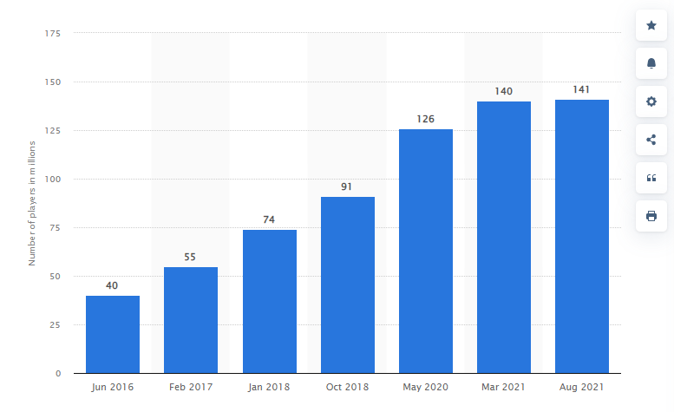

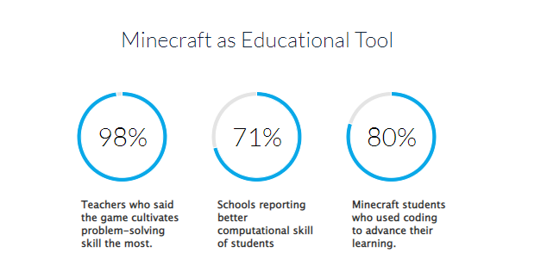

Schools in different countries use it as an educational tool for kids:

* 98% of teachers who used Minecraft in their class reported that the number one skill the game teaches students is problem-solving.
* Other top skills nurtured by Minecraft include collaboration, communication and decision-making skills, soft skills that 40% of jobs in growth industries require.
* 80% of Minecraft students used coding to advance their education.
* 71% of schools are using digital games as a learning tool reported improvement in student numeracy and computational thinking.

Key points:

* In terms of unit sales, Minecraft is second among the best-selling games ever: 1) Tetris (495 million); 2) Minecraft (180 million);.
* But compared with other best-selling games, Minecraft is enduring. In 2019, it is still the 13th best in terms of sales.
* Minecraft is the third most popular video game among American preteens as of September 2019: 1) Roblox (33%); 2) Fortnite (26%); 3) Minecraft (24%).
* As of last quarter 2018, Minecraft is fourth in the share of fans among selected best-selling games worldwide: 1) Plants vs. Zombies (18%); 2) FIFA (17%); 3) Mario (17%); 4) Minecraft (12%).
* At nearly the same time, Minecraft is the top paid app on Google Play worldwide in terms of the number of days:  1) Minecraft (1,944); 2) Poweramp (1,275);
* Outside of gaming, Minecraft proves popular as well. Among the top YouTube channel views of all time, a channel dedicated to the game came fifth in billion views: 1) Ryan’s World (35.18); 2) PewDiePie (24.44); 3) Like Natasya Vlog (22.68); 4) Kids Diana Show (17.01); 5) DanTDM’s TheDiamondMinecraft (16.01).

There are 54 589 servers that covers an enormous amount of players. This industry is high income flowing business, the average Minecraft server with a stable online of 150 players can bring 1100 – 1600 dollars.

Users can register, buy donation, prefixes, upload their own files,data for viewing later. What’s more, it is always possible to make a donation at any time.

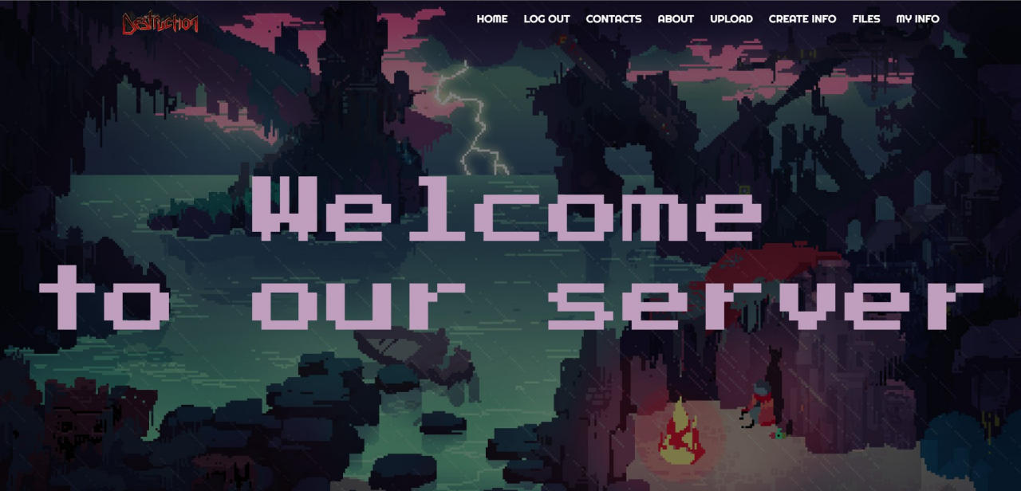

*Picture 1. The screenshot of Destruction Minecraft server*

There are very little amount of minecraft servers in Kazakhstan. One of the most popular is Destruction minecraft server. As can be seen from the screenshot, the website has a typical structure: navigation bar (includes different types of donation, personal info, data), the main page with great theme. There is a offering system, login/registration, personal resume, files.

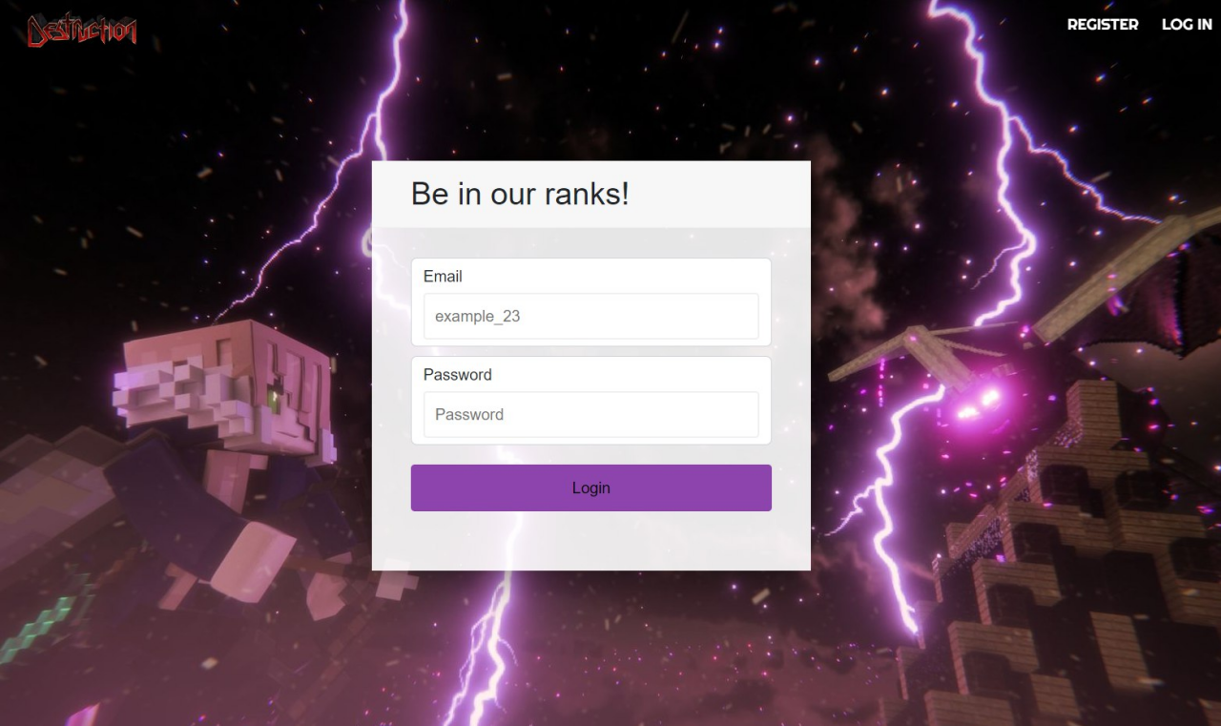

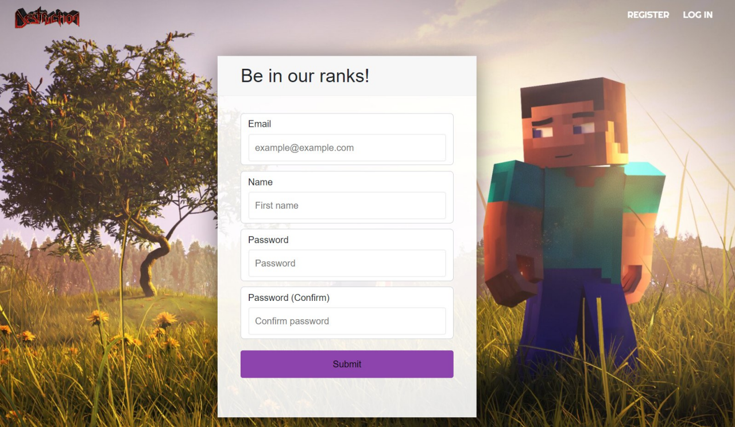

*Pictures 2. Destruction Register/Login*

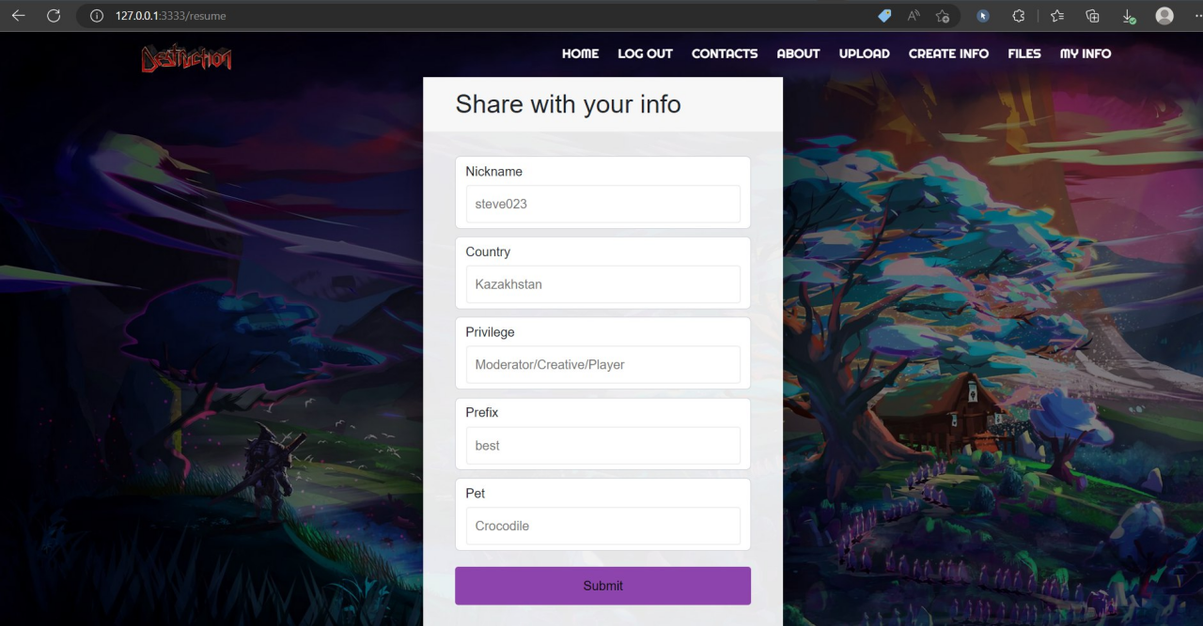

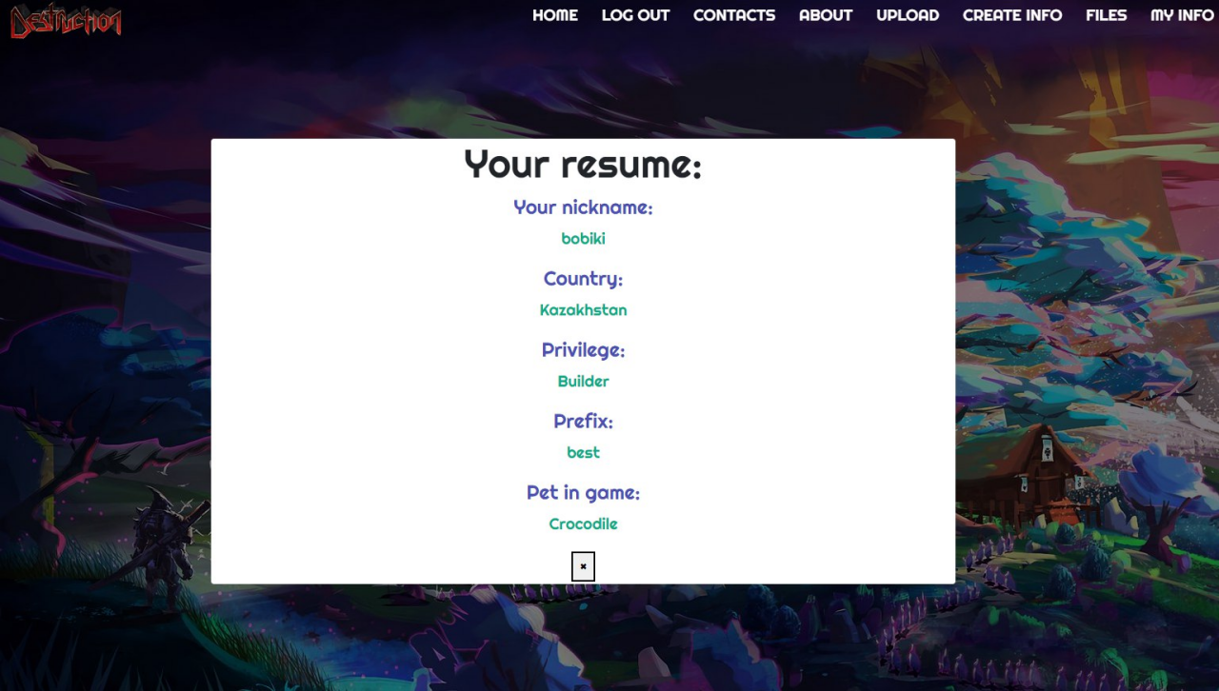

*Pictures 3. Destruction personal info pages*

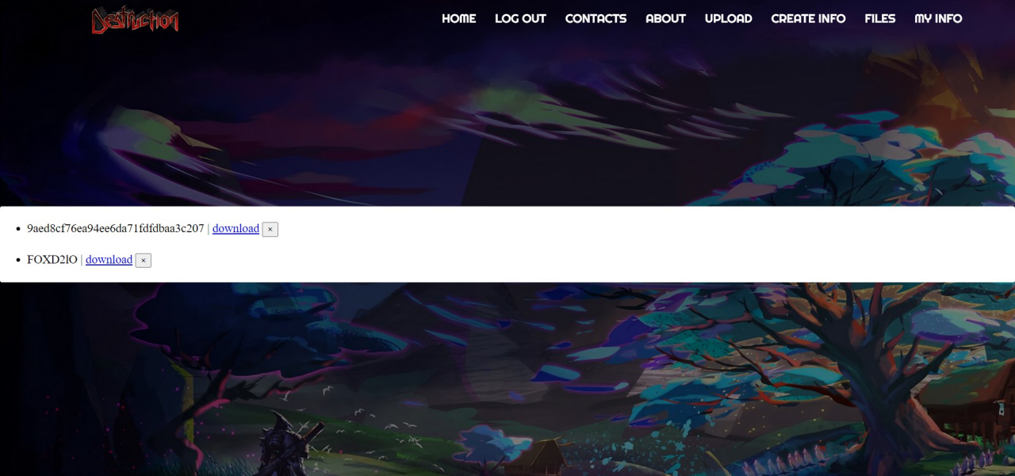

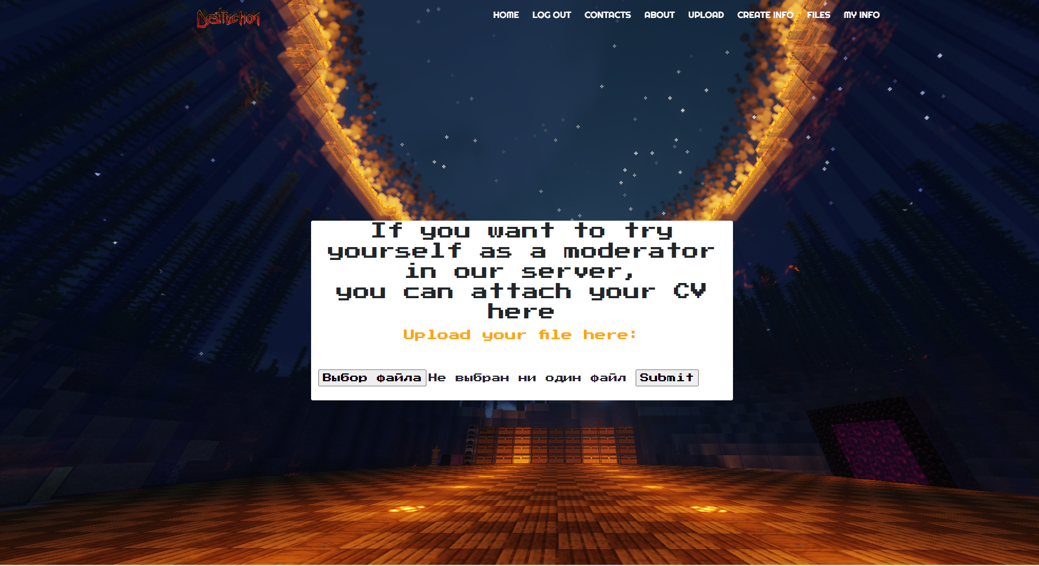

*Pictures 4. Destruction File Upload system*

Player info will be helpful to find the friends and see the player statistics(in the future). Administrators will use your data in purpose to help you in some problematic issues, only with your permission. Storing your personal data, skins, sceenshots from rankup game from minecraft server one of the best sides of the Destruction minecraft server.

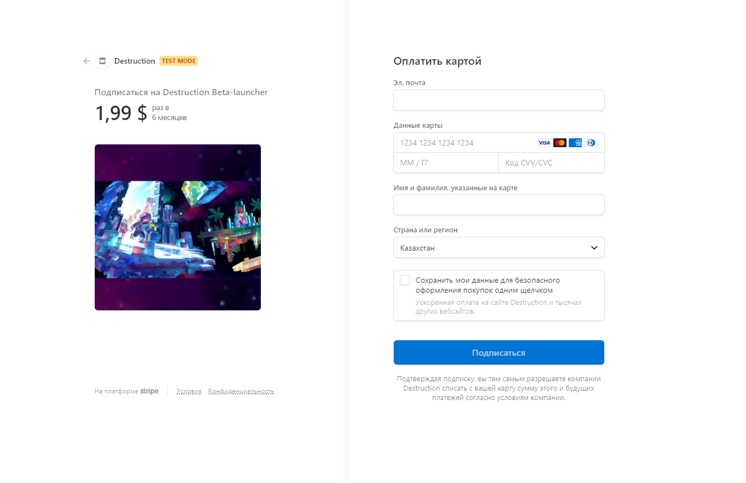

*Picture 5. Destruction order processing*

When you make an order, it is necessary to be logged, u can use your card to pay for donations and show the best ingame experience

**Project auditory.**

***Age of 7+***

From this age we provide friendly community, active administrators for the gentle and innocent gameplay. From this age, its recommended to play in educational purpose. Users from this auditory can’t make donations.

***Age of 13+***

Gamers from this age are able to make donations, but can’t apply to be the administrator(by uploading cv)

***Age of 18+***

From this age, users can do anything, use all functionalities of Destruction minecraft server. Only from 18+, we choose the most active administrators and give them best donations in purpose to create naïve community

**Project features.**

Our server does not require special unique functionality. It must have a donations with better in game experience, where users can set specific prefixes, benefits. It also must have a personal account information, skins. Login and registration are required to make an order for donations.